PRACTICE PROGRAM(07-08-2024)

1. Take and compile pattern AB(your expression) input is” AB ABC ABCC ABC BC” Write a program to check whether the pattern is present in input string and how many times its present

Program:

import java.util.regex.Matcher;

import java.util.regex.Pattern;

public class PatternMatcher {

public static void main(String[] args) {

String input = "ABABCABCCABCBC";

String pattern = "AB";

Pattern p = Pattern.compile(pattern);

Matcher m = p.matcher(input);

int count = 0;

while (m.find()) {

count++;

System.out.println("Pattern found at index " + m.start());

}

System.out.println("Pattern found " + count + " times.");

}

} 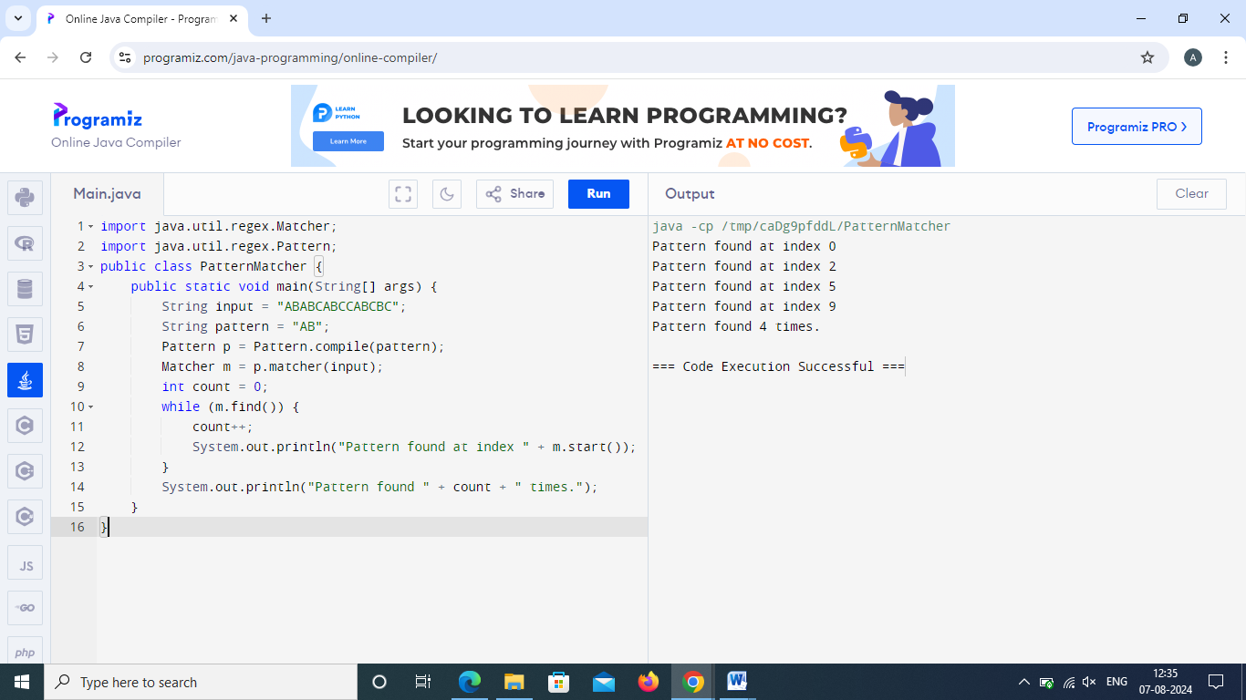

1. Regular expression patterns match

import java.util.regex.Matcher;

import java.util.regex.Pattern;

public class pattern{

public void count(String pattern){

String input="ABABCABCCABCBC";

Pattern p=Pattern.compile(pattern);

Matcher m=p.matcher(input);

int count=0;

while (m.find()){

count++;

}

System.out.println("The pattern '"+pattern+"' occurs "+count+" times");

}

public static void main(String[] args){

pattern p=new pattern();

p.count("AB");

p.count("[^AB]");

p.count("[a-z]");

p.count("[A-Z]");

p.count("a-zA-Z");

p.count("[0-9]");

p.count("[a-zA-Z0-9]");

p.count("[^a-zA-Z0-9]");

}

} 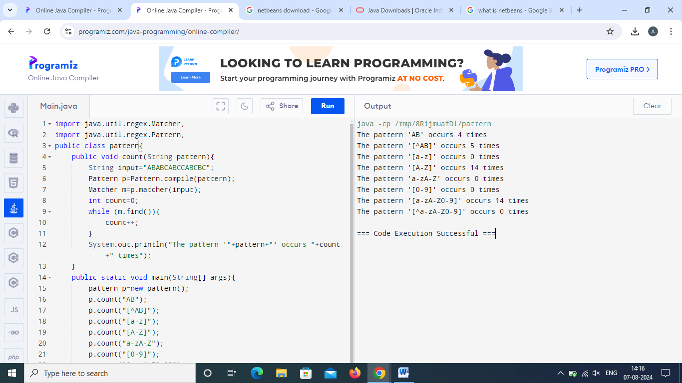

3] split the given string using slash, space and dot.

public class StringSplitter{

public static void main(String[] args){

String input="hello/world.this is a test.string";

String[] splitStrings=input.split("[/. ]");

System.out.println("Split strings:");

for (String s:splitStrings){

System.out.println(s);

}

}

}

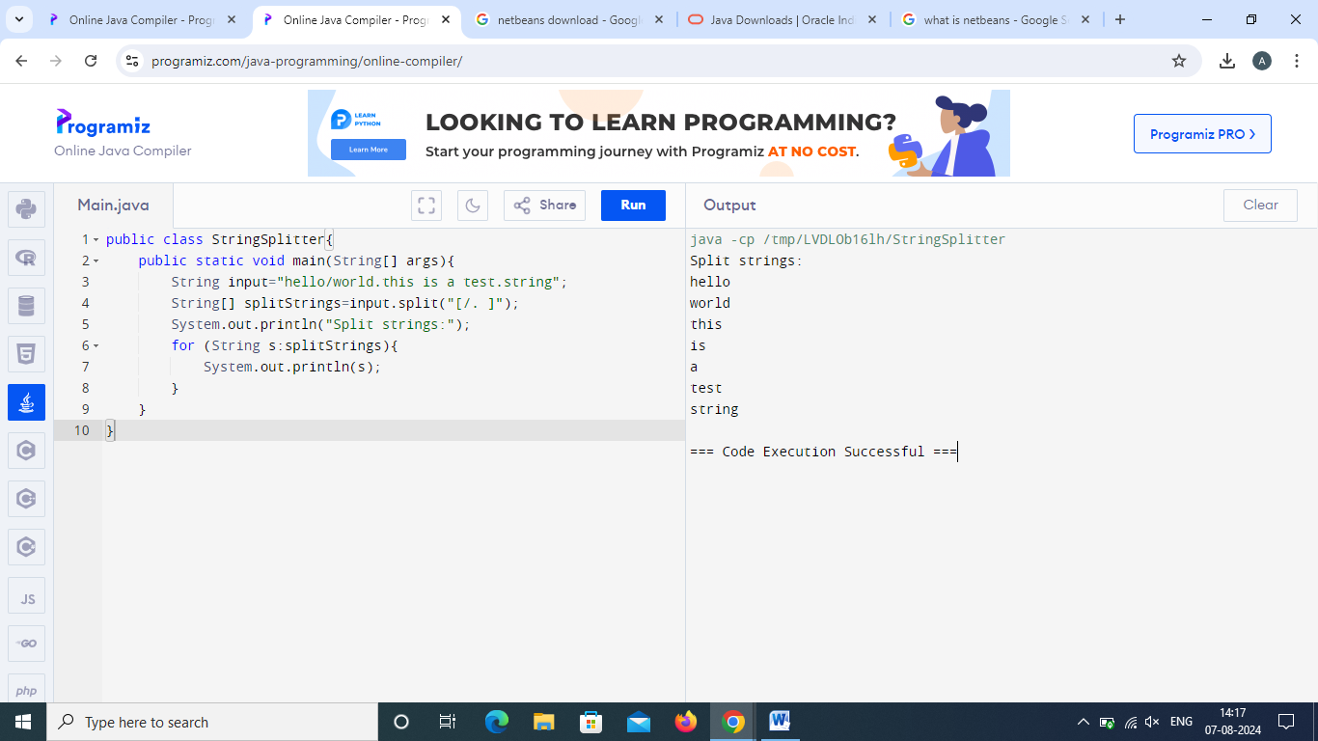

4] Quantifier

import java.util.regex.Matcher;

import java.util.regex.Pattern;

public class pattern{

public void count(String pattern){

String input="ABABCABCCABCBC";

Pattern p=Pattern.compile(pattern);

Matcher m=p.matcher(input);

int count=0;

while (m.find()){

count++;

}

System.out.println("The pattern '"+pattern+"' occurs "+count+" times");

}

public static void main(String[] args){

pattern p=new pattern();

p.count("[A+]");

p.count("[A\*]");

p.count("[A?]");

p.count("[AB{1,3}]");

p.count("[AB{1}]");

}

} 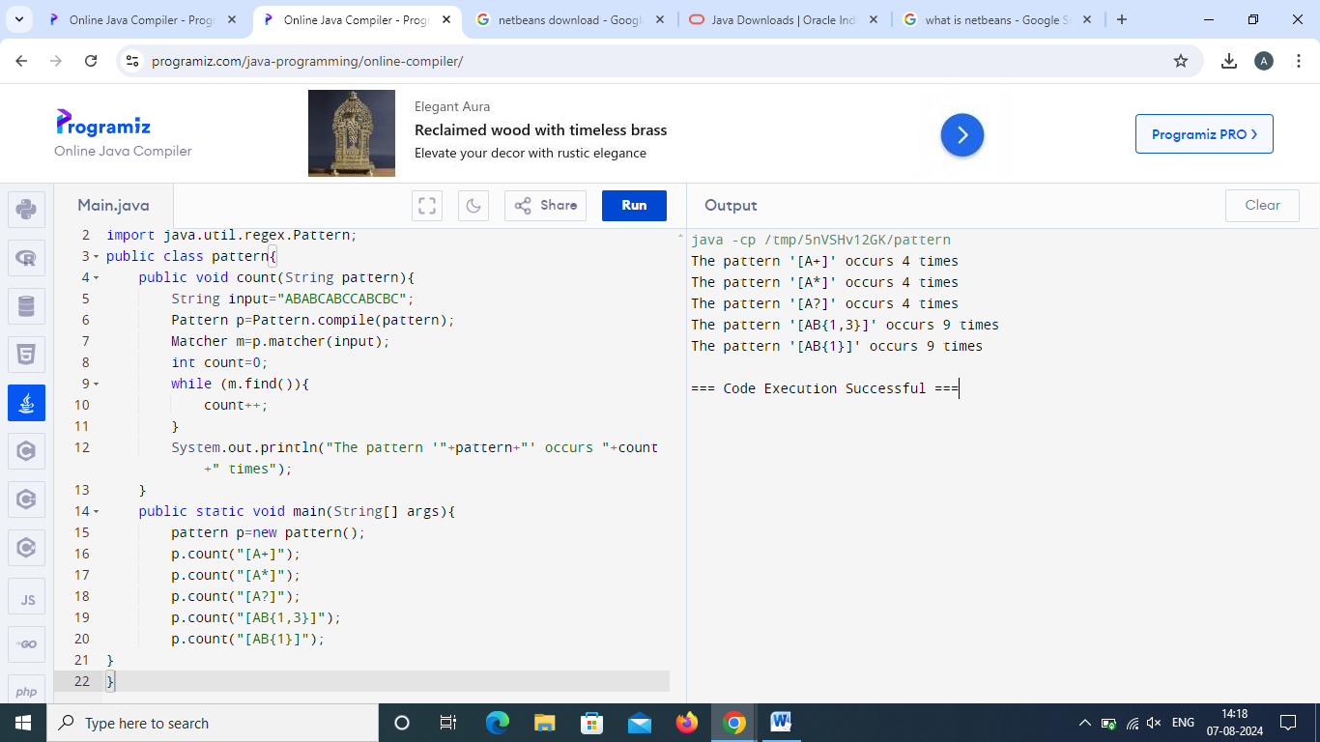

5] Regular Expressions

import java.util.regex.Matcher;

import java.util.regex.Pattern;

public class pattern{

public void count(String pattern){

String input="ABABCABC CABCBC000";

Pattern p=Pattern.compile(pattern);

Matcher m=p.matcher(input);

int count=0;

while (m.find()){

count++;

}

System.out.println("The pattern '"+pattern+"' occurs "+count+" times");

}

public static void main(String[] args){

pattern p=new pattern();

p.count("\\bAB"); //start with

p.count("AB\\b"); //end with

p.count("\\d");

p.count("\\s");

p.count("\\w");

}

} 